产品规格书
Products Specification

产品名称 Title:开关电源 Switching Power Supply

产品型号 Model: ESG-200-24

设计号 Design NO: ECU2.939.10666

日期Date | 2025.3.21
版本Rev | A00
设计Designed | 田朗
审核Checked
批准Approved

地址：安徽省合肥市高新区习友路3366号
ADD：No. 3366XiYou Rd, Hefei, Anhui, 230000
电话：+86-400-665-9997
TEL：+86-400-665-9997
邮箱：sales@ecu.com.cn
E-mail：sales@ecu.com.cn
网址：//www.ecu.com.cn
http://www.ecu.com.cn

版本更改记录Revisions

版本  Rev | 日期  Date | 更改说明  Description | 核准  Approved
A00 | 2025-03-21 | 第一次发行

目录
1.基本参数Basic Parameter 1
2.技术特性 Technical Characteristics 1
2-1 输入特性 Input Characteristics 1
2-2 输出特性Output Characteristics 1
2-3 保护功能 Protection Function 2
2-4安规&电磁兼容Safety& EMC 3
2-5可靠性 Reliability 4
3.环境要求 Environment Requirement 4
4机械规格 Mechanism Specification 5
4-1 产品尺寸 Product Dimension 5
4-2 产品重量 Product Weight 5
4-3产品装配示意图 Product Assembly 6
4-4放置示意图Standard Mounting 7
5. 降额曲线Derating Curve 7

1.基本参数Basic Parameter
输出电压  Output Voltage | 电压调整范围  Voltage Regulation Range | 噪声+纹波  Noise & Ripple | 最小负载  Min.Load | 最大负载  Max.Load
24V | ±10% | 150mV | 0A | 8.3A

备注 Note：
1）电源最大持续输出功率200W。
Maxcontinuous output power 200W.
- 输出电压通过可调电阻调节。
Output voltage is regulated by an adjustable resistor .

2.技术特性Technical Characteristics

2-1 输入特性Input Characteristics
项目  Item | 单位  Unit | 最小值  Min | 额定值  Rated | 最大值  Max | 备注  Remark
输入电压  Input Voltage | Vac | 90 | 115 | 132 | 通过拨动开关选择输入电压范围，“115”对应90-132Vac输入，“230”对应180-264Vac输入。  Different input voltage ranges can be chosen by switch, “115” means 90-132Vac, “230” means 180-264Vac.  最大300Vac ,持续时间5秒。  Max 300Vac input, continue 5S.
输入电压  Input Voltage | Vac | 180 | 230 | 264
输入频率  Input Frequency | Hz | 47 | 50/60 | 63
输入电流  Input Current | A | / | / | 2.5 | 230Vac,满载Full Load.
 |  |  |  | 4.0 | 115Vac,满载Full Load.
输入冲击电流  Inrush Current | A | / | / | 30 | 115Vac,满载,冷启动Full load,cold start.
输入冲击电流  Inrush Current | A | / | / | 60 | 230Vac,满载,冷启动Full load,cold start.
空载功耗  No-load power consumption | W |  |  | 3 | 230Vac,空载/No Load.

2-2 输出特性Output Characteristics

项目  Item | 单位  Unit | 最小值  Min | 额定值  Rated | 最大值  Max | 测试条件  Test Conditions
输出电流  Output Current | A | 0 | / | 8.3 | 24V输出，参照降额曲线Test@24V output，refer to derating curve
负载调整率  Load Regulation | / | / | / | ±1% | 输入电压范围内测试，参照降额曲线  Test within input voltage range specified,refer to derating curve
线性调整率  Line Regulation | / | / | / | ±0.5% | 负载范围内测试，参照降额曲线  Test within load range specified,refer to derating curve
电压误差  Voltage Tolerance | / | / | / | ±1% | 参照降额曲线  Refer to derating curve
输出纹波噪声  DC Output Ripple&Noise | mVp-p | / | / | 150 | 参照备注1  Refer to Note 1
效率  Efficiency | / | 87% | / | / | 输入Input：230Vac  输出Output：24Vdc,满载Full load.
动态负载  Dynamic Load | / | / | / | ±5%Vout | 输入Input：115/230Vac，50-100%负载load,1A/uS，50-10K Hz
开机延迟时间  Setup Time | mS | / | / | 3000 | 输入Input：115/230Vac,  输出Output：24Vdc,满载Full Load.
输出上升时间  DC Output Voltage Rise Time | mS | / | / | 50 | 输入Input：115/230Vac,  输出Output：24Vdc,满载Full Load.
输出保持时间  DC Output Hold-up Time | mS | 10 | / | / | 输入Input：115Vac,  输出Output：24Vdc,满载Full Load.
输出保持时间  DC Output Hold-up Time | mS | 16 | / | / | 输入Input：230Vac,  输出Output：24Vdc,满载Full Load.
开关机过冲  Overshoot | V | / | / | ±5%Vout | 输入Input：115/230Vac
备注Note:
- 输出纹波噪声测试条件DC output ripple & noise test conditions
a)使用12英寸（300mm）的双绞线将电源连接至负载，同时在负载端并联0.1uF陶瓷电容和47uF电解电容。
Connect 12”（300mm）twisted cables to the load, parallel 0.1uF ceramic and 47uF electrolytic capacitor to the load terminal.
b)示波器须设置在20M赫兹带宽，在负载端进行测试。
Oscilloscope probe, 20MHz bandwidth-limited, placed across the load terminals.
2)电源OK指示
电源绿色发光二极管发光时表明电源工作。
Green LEDs emit light to indicate the power supply is working.

2-3 保护功能 Protection Function
项目  Item | 范围  Range | 注释  Comments
输出过压保护  Output Over Voltage Protection | 115~180% | 故障移出后,电源自动恢复。  Recovers automatically after fault condition is removed.
过载保护  Over load Protection | 105~150% | 故障移出后,电源自动恢复。  Recovers automatically after fault condition is removed.
输出短路保护  Output Short Circuit Protection | / | 故障移出后,电源自动恢复。  Recovers automatically after fault condition is removed.
过温保护  Over Temperature  Protection | / | 内部关键元器件温度达到一定范围时，关断输出，自动恢复。  Temperature of internal key components reaches a certain range, disconnect output, recovery automatically.

2-4安规&电磁兼容Safety& EMC
安规Safety：
设计参照下列标准Design refers to the following standards:
GB4943.1
EN62368-1

项目  Item | 测试方法  Test Method | 测试条件&性能标准  Test Conditions& Performance Standards
绝缘耐压  Dielectric strength:(Hi-pot) | 输入-输出 Input to Output | 3000Vac，60S，≤10mA
绝缘耐压  Dielectric strength:(Hi-pot) | 输入-地 Input to FG | 1500Vac，60S，≤10mA
绝缘耐压  Dielectric strength:(Hi-pot) | 输出-地 Output to FG | 500Vac，60S，≤10mA
绝缘阻抗  Isolation Impedance | 输入-输出 Input to Output | 500Vdc，60S，≥100MΩ (室温70%湿度@room temperature，70% RH )
绝缘阻抗  Isolation Impedance | 输入-地 Input to FG | 500Vdc，60S，≥100MΩ (室温70%湿度@room temperature，70% RH )
绝缘阻抗  Isolation Impedance | 输出-地 Output to FG | 500Vdc，60S，≥100MΩ (室温70%湿度@room temperature，70% RH )
泄露电流  Leakage current | / | 240Vac，50Hz，≤3.5mA

电磁兼容EMC：
项目  Item | 测试标准  Test Standard |  | 性能标准  Performance Criterion
传导干扰  Conducted Emission | EN55032:2015 Class A |  | /
辐射干扰  Radiated Emission | EN55032:2015 Class A |  | /
电压波动和闪烁抗扰度  Voltage fluctuation & Flicker immunity | EN61000-3-3:2013  Pst: 1.0  Plt: 0.65  Tdt:500ms  dmax(%):4%  Dc(%):3.3% |  | Criterion A
静电放电抗扰度  Electrostatic discharge immunity | IEC61000-4-2  Air Discharge：±8kV  Contact Discharge：±4kV |  | Criterion A
射频电磁场辐射抗扰度  Radiated, Radio frequency electromagnetic field immunity | IEC61000-4-3  Frequency Range: 80MHz-1000MHz  3V/m |  | Criterion A
电快速瞬变脉冲群抗扰度  Electrical fast transient pulse group immunity | IEC61000-4-4  AC Power Ports:±1kV  Signal Ports and Telecommunication Ports:0.5kV |  | Criterion B
浪涌抗扰度  Surge immunity | IEC61000-4-5  Common Mode: 2kV；Differential Mode: 1kV |  | Criterion A
射频场感应的传导干扰抗扰度  Conducted interference immunity induced by RF field | IEC61000-4-6  Frequency Range：0.15MHz-80MHz  3Vms |  | Criterion A
电源频率磁场抗扰度  Power frequency magnetic field immunity | IEC61000-4-8  1A/m |  | Criterion A
电压暂降短时中断和电压变化抗扰度  Voltage dips Short interruption and voltage change immunity | IEC61000-4-11 | Voltage Dips  >95% reduction,0.5 period | Criterion A
 | IEC61000-4-11 | Voltage Dips  30% reduction,25 period | Criterion B
 | IEC61000-4-11 | Voltage interruptions  >95% reduction,250 period | Criterion B
*注释Comments：
Criterion A：在技术规范内性能正常
Normal performancewithin technical specifications.
Criterion B：功能或性能暂时降低或丧失，但能自行恢复
Temporary reduction or loss of function or performance, but self-recovery.

2-5可靠性 Reliability

电源老化 Burn-in test
电源在输入 230Vac(50Hz) ,满载,温度40±5℃条件下老化测试.
The power supply is subjected to burn-in test at input 230Vac(50Hz), full load and temperature of 40±5℃.

平均无故障时间MTBF
200k小时 hour（MIL-HDBK-217F, 25℃）

3.环境要求 Environment Requirement

项目  Item | 单位  Unit | 最小值  Min | 典型值  Rated | 最大值  Max | 备注  Remark
温度  Temperature | ℃ | -30 | 25 | 70 | 工作温度Operation Temperature  (-20摄氏度可在输入电压范围内启动，-30摄氏度可在230Vac启动  The power supply can be started at -20℃ within the input voltage range, and be started at -30℃,230Vac)  参照负载降额曲线Refer to derating curve
温度  Temperature | ℃ | -40 | 25 | 80 | 贮藏温度Storage Temperature
相对湿度  Relative humidity | RH | 5% |  | 95% | 工作湿度Operation Humidity  无凝露 Without Condensation
相对湿度  Relative humidity | RH | 5% |  | 95% | 贮藏湿度Storage Humidity  无凝露 Without Condensation
冷却方式  Cooling Mode | 空气自然冷却 Air Cooling
振动  Vibration | 10~500Hz，5G 10分钟/周期，X、Y、Z轴各60分钟  10~500Hz，5G 10min/ 1cycle,period for 60 min each along X,Y,Z axes
海拔高度  Altitude | ≤5000m(参照备注1Refer to Note 1)
备注Note:
- :当操作海拔高于2000米（6500ft）时，操作环温需调降5摄氏度/1000米。
- :When the operating altitude is higher than 2000m(6500ft),the operating ambient
temperature should be lowered by 5℃/1000m.

4机械规格 Mechanism Specification

4-1 产品尺寸 Product Dimension

长215毫米*宽115毫米*高30毫米; L215mm * W115mm * H30mm .

4-2 产品重量 Product Weight

重量Weight：0.7Kg/PCS

4-3产品装配示意图 Product Assembly

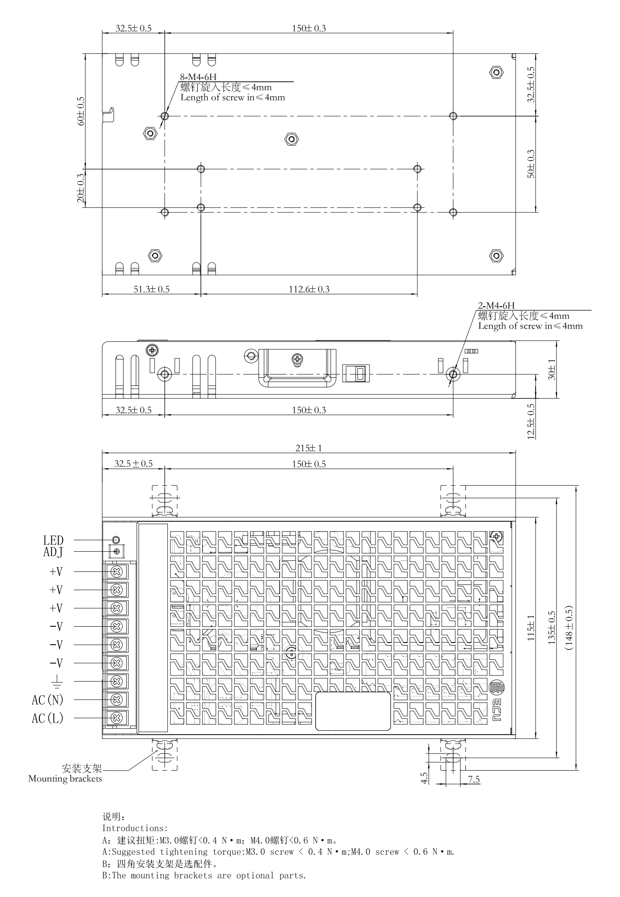

4-4放置示意图Standard Mounting

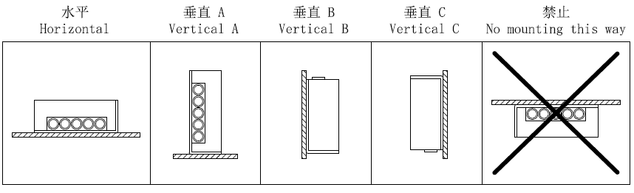

降额曲线Derating Curve
